**SQL Assignment 3**

**Query 1 write a SQL query to find Employees who have the biggest salary in their Department**

select emp_name,emp_id,employee.dept_id,salary,dept_name from employee inner join department on department.dept_id = employee.dept_id where salary IN (select max(salary) from employee group by employee.dept_id) ;

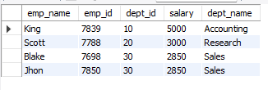

**Query 2. write a SQL query to find Departments that have less than 3 people in it**

select dept_name,department.dept_id from employee inner join department on department.dept_id = employee.dept_id group by dept_id having(count(emp_id)<3);



**Query 3. write a SQL query to find All Department along with the number of people there**

select department.dept_id,dept_name,count(emp_id) from employee inner join department on department.dept_id = employee.dept_id group by dept_id;

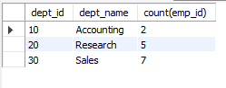

**Query 4. write a SQL query to find All Department along with the total salary there**

select department.dept_id,dept_name,sum(salary) from employee inner join department on department.dept_id = employee.dept_id group by dept_id;

